**Introduction to Programming in R**

From basics to Advanced

**Md. Neaz Ali**

M.Sc in Statistics

Department of Statistics

Islamic University, Kushtia – 7003, Bangladesh

Email: [neazali77@gmail.com](mailto:neazali77@gmail.com)

Contents

Chapter 1 Introduction to R Software 3

1.1 Obtaining R and RStudio 3

1.2 RStudio Interface 3

1.3.1 Console 3

1.3.2 Editor 3

1.3.3 Workspace, History 3

1.3.4 File, Plots, Packages, Help 4

1.4 Starting out – setting a working directory 4

1.5 R as a big calculator 4

1.6 A few important points on R 4

1.7 Operators in R 5

1.7.1 Arithmetic Operators 5

1.7.2 Logical Operators 5

1.7.3 Relational Operators 5

1.7.4 Assignment Operators 6

1.7.5 Miscellaneous Operators 6

1.8 Variables in R programming 6

1.9 Data Types in R Programming 6

1.10 Useful Functions in R e.g. rm(), ls() 7

1.11 Data Sets in R and save R Session 7

1.12 Installing new R Libraries 8

Chapter 2 Objects in R 9

2.1 Types of R Objects 9

2.2 Attributes of R Objects 10

2.2.1 Basic Attributes 10

2.2.2 Other Attributes, dimension 10

2.3 Creating and Accessing Objects 10

2.4 Modifying elements 11

2.4.2 Missing Values 12

2.4.3 Creating Empty Vectors and Matrices 12

2.5 Quick Recap 12

2.6 Exercise 1 13

# Chapter 1 Introduction to R Software

## 1.1 Obtaining R and RStudio

R can be downloaded from the website: [Download R-4.4.2 for Windows. The R-project for statistical computing.](https://cran.rstudio.com/bin/windows/base/) and R-Studio can be downloaded from the website: [RStudio Desktop - Posit](https://posit.co/download/rstudio-desktop/)

## 1.2 RStudio Interface

RStudio is a free and an open source integrated development environment for R. On startup R Studio brings up a window with 3 or 4 panels. If you only see 3 panels, click on *File 🡪 New 🡪 New R Script.*

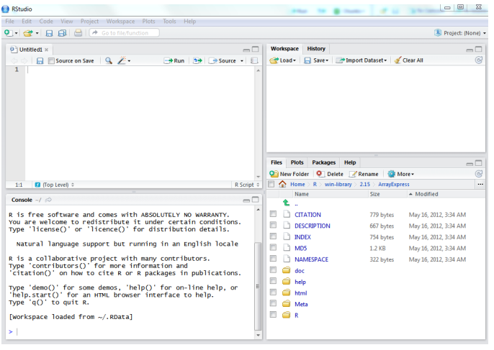

The bottom left panel “console” is the exact same as the standard R console. RStudio just loads your local version of R. You can specify a different version of R (if you have multiple versions of R running on your machine) by clicking on *Tools 🡪 Options*  and selecting R version.

### 1.3.1 Console

RStudio has a nice console features

* Start typing a command, for example fi*,* press the TAB key, it will suggest function that begin with fi
* Select fisfor fishers.test

### 1.3.2 Editor

The top left panel is an editor which can be used to edit R scripts (.R), plain text (.txt), html web files or any other files. There are several nice features to this text editor which we will describing in the following sections. But for this time being note, that it highlights R code, and that the code is searchable.

### 1.3.3 Workspace, History

On the top right there is a tab menu workspace and history.

* It lists the object in the current R session. You can load, save or “Clear All” objects for a workspace.
* There is the option to **Import Dataset.**
* The history panel lists all of the command that have been types or input in the console.

### 1.3.4 File, Plots, Packages, Help

On the bottom right there is a tab menu Files, Plots, Packages, and Help.

* **Files** is the file browser, which allows you to create a new folder, rename a folder or delete a folder.
* The **Plots** window displays plots generated in R. Simply type the following command into the Console window

|  |
| --- |
| plot(1:10)  plot(rnorm(10), 1:10) |

* **Packages** lists all of the packages installed in you computer. The packages with a tick marked are those loaded in your current R session. Click on a package name to view help on that package. Note that you can **install packages or check for updates.**

|  |
| --- |
| instll.packages(“packagename”)  # load the package  library(packagename) |

* The **Help**  menu provides an extensive R help.

|  |
| --- |
| ?mean()  help(mean) |

## 1.4 Starting out – setting a working directory

The first thing to do when starting an R session, is to ensure that you will be able to find your data and also that your output will be saved to a useful location on your computer hard-drive. Therefore, set a **working directory**.

There are numerous ways to set the **working directory**. To change directory:

1. In the classic R interface. Use the file menu, to change directory *File 🡪 Change dir.*
2. If you start R by clicking on an R icon. You may wish to change the default start location by right mouse clicking on the R icon on the desktop/start menu and changing the **Start In** property.
3. In RStudio Tools 🡪 **Set Working Directory.**
4. Use the **File** browser window to view the contents of a directory and navigate to the directory you wish to set as you home directory.
5. The commands to set the working directory

|  |
| --- |
| # What is my current directory  getwd()  # To Change the directory  setwd(“File Path”) |

1. Creating a R Project: Top right corner of the window and following along with your desired name of the project and the directory to create a R project.

## 1.5 R as a big calculator

Type the following into an R session.

|  |
| --- |
| 2 + 2  ## [1] 4  2 * 2  ## [1] 4  2 * 100 / 4  ## [1] 52 |

## 1.6 A few important points on R

Elementary commands: *expressions* are evaluated, printed and value lost; *assignments* evaluate expression, passes value to a variable, but not automatically printed

|  |
| --- |
| 2 * 5 ^ 2  ## [1] 50  x = 2 * 5 ^ 2  print(x)  ## [1] 50 |

## 1.7 Operators in R

Operators are the symbols directing the compiler to perform various kinds of operators between the operands e.g.

|  |
| --- |
| 2 + 4 |

Here 2 and 4 are operands and (+) is the operator which is performing addition operation on the both operand 2 and 4.

R support majorly four kinds of binary operators between a set of operands. Namely they are

* Arithmetic Operators
* Logical Operators
* Relational Operators
* Assignment Operators
* Miscellaneous Operators

### 1.7.1 Arithmetic Operators

Arithmetic operators modulo using the specified operator between operands, which may be either scalar value, complex numbers, or vectors. The most common arithmetic operators are

* Addition (+): 5+4
* Subtraction (-): 4-2
* Multiplication (*): 7*2
* Division (/): 10/2
* Power (^): 2^5
* Modulo (%%): 24 %% 5

### 1.7.2 Logical Operators

Logical operators in R simulate element-wise decision operations, based on the specified operator between the operands, which are then evaluated either a TRUE or FALSE value.

* Element-wise Logical AND operator (&): TRUE & TRUE = TRUE (if both side are true then result is true).
* Element-wise Logical OR operator (|): TRUE | FALSE = TRUE (if at least one side is true then result is true).
* NOT operator (!): A unary operator that negates the status of the elements of the operand. ! TRUE = FALSE.
* Logical AND operator (&&): Returns TRUE if both the first element of the operands is True.
* Logical OR operator (||): Return TRUE if either of the first elements of the operands is True.

### 1.7.3 Relational Operators

The Relational Operators in R carry out comparison operations between the corresponding elements of the operands. Returns a Boolean TRUE value if the first operand statisfies the relation compared to the second.

* Less than (<): 5 < 10 (TRUE)
* Greater than (>): 5 > 10 (FALSE)
* Less than equal to (<=): 5 <= 10 (TRUE)
* Greater than equal to (>=): 5 >= 10 (FALSE)
* Not equal to (!=): 5!=10 (TRUE)
* Equal to (==): 5 == 10 (FALSE)

### 1.7.4 Assignment Operators

Assignment operators in R are used to assigning values to various data objects in R. the objects may be integers, vectors, functions, or dataframes etc. There are two kinds of assignment operators: Left and Right

* Left assignment (<-): vec1 <- c(“ab”, TRUE)
* Right assignment (->): c(“ab”, TRUE) -> vec2
* Or Simply equal to (=): vec1 = c(“ab”, TRUE)

N.B: Operations in programming flows from right to left and up to bottom manner.

### 1.7.5 Miscellaneous Operators

Miscellaneous operators are the mixed operators in R that simulate the printing of sequences and assignment of vectors, either left or right – handed.

* **%in% Operator**: Checks if an element belongs to a list and returns a Boolean value TRUE if value is present else FALSE e.g.,

|  |
| --- |
| val = 0.1  list1 = c(TRUE, 0.1, “apple”)  print(val %in% list1) |

* **%*% Operator**: This operator is used to multiply a matrix with its transpose. Transpose of the matrix is obtained by interchanging the rows to columns and columns to rows.

|  |
| --- |
| mat = matrix(c(1,2,3,4,5,6),nrow=2,ncol=3)  print (mat)  print( t(mat))  pro = mat %*% t(mat)  print(pro) |

## 1.8 Variables in R programming

A variable is a memory allocated for the storage of specific data and the name associated with the variable is used to work around this reserved block. The name given to a variable is known as its variable name. Usually a single variable stores only the data belonging to a certain data type.

|  |
| --- |
| var1 = "hello"  print(var1) |

Rules for Variable Naming:

* A valid variable name consists of a combination of alphabets, numbers, dot(.), and underscore(_) characters. Example: var.1_ is valid
* Apart from the dot and underscore operators, no other special character is allowed. Example: var$1 or var#1 both are invalid
* Variables can start with alphabets or dot characters. Example: .var or var is valid
* The variable should not start with numbers or underscore. Example: 2var or _var is invalid.
* If a variable starts with a dot the next thing after the dot cannot be a number. Example: .3var is invalid
* The variable name should not be a reserved keyword in R. Example: TRUE, FALSE, etc.

N.B.: Always use relative names for variables for better understanding the work of the variable.

## 1.9 Data Types in R Programming

**R Data types** are used to specify the kind of data that can be stored in a variable. For effective memory consumption and precise computation, the right data type must be selected. Each R data type has its own set of regulations and restrictions. Variables are not needed to be declare with a data type in R, data type even can be changed. Data types in R are:

* Numeric – (3, 6.7, .121)
* Integer – (2L, 42L; where ‘L’ declares this as an integer)
* Logical – (TRUE)
* Complex – (7+5i; where ‘I’ is imaginary number)
* Character – (“a”, “B”)
* Raw – (as.raw(55); raw creates a raw vector of the specified length)
* String – (“Hello World”)

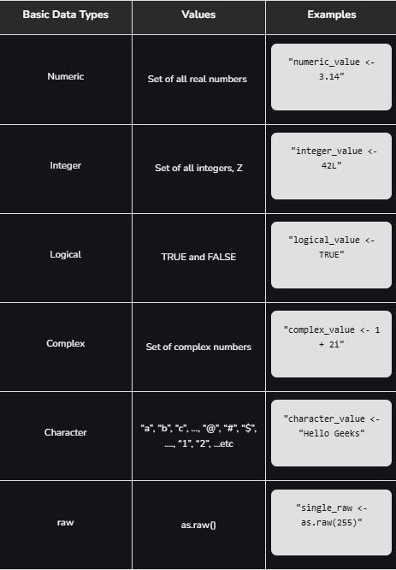

## 1.10 Useful Functions in R e.g. rm(), ls()

|  |
| --- |
| ls(); List all the objects currently defined in your R workspace.   * ls(pattern = “my_var”)   rm(); Removes the specified objects.   * rm(“var1”) * rm(list = ls() |

## 1.11 Data Sets in R and save R Session

For R session you may visit this site: [R tutorials, R session, enter, leave, quit](http://countbio.com/web_pages/left_object/R_for_biology/R_fundamentals/R_sessions.html)

Both the R core installation and contributed R package contain datasets, which are useful example data when learning R. To list all available datasets:

|  |
| --- |
| data() |

To load a dataset, for example, the dataset women which gives the average heights and weights for 15 American women aged 30-39.

|  |
| --- |
| data(women)  ls()  ls(pattern = “s”) |

To finish up today, we will save our R session and history.

1. R session One can either save one or more R object in a list to a file using *save()* or save the entire R session using *save.image().*

|  |
| --- |
| save(women, file = “women.RData”)  save.image(file = “entiresession.RData”) |

1. To load this into R, start a new R session and use the *load()*

|  |
| --- |
| rm(women)  ls(pattern = “women”)  load(“women.RData”)  ls(patterns = “women”) |

1. R history records the commands history in an R session. To view most recent R commands in a session

|  |
| --- |
| history()  help(history)  history(100)  savehistory(file = “L2.Rhistory”) |

## 1.12 Installing new R Libraries

Packages in [R Programming language](https://www.geeksforgeeks.org/introduction-to-r-programming-language/) are a set of [R functions](https://www.geeksforgeeks.org/functions-in-r-programming/), compiled code, and sample data. These are stored under a directory called “library” within the R environment. By default, R installs a group of packages during installation. Once we start the R console, only the default packages are available by default. Other packages that are already installed need to be loaded explicitly to be utilized by the R program that’s getting to use them. There are several thousand R packages and >500 Bioconductor packages (also called libraries) available. These are not installed by default, so we have to select and install additional packages that will be of use to us. To install packages from cran use the following command

|  |
| --- |
| install.packages(“packageName”) # e.g. packageName = ggplot2 |

To load a package into the session use the following command

|  |
| --- |
| library(packageName) # e.g. packageName = ggplot2 |

Update packages

|  |
| --- |
| install.packages(“lme4”)  update.packages(“lme4”)  library(help = lme4) |

Or

|  |
| --- |
| library(lme4) # Load a package  ## Or the alternative  require(lme4)  sessionInfo() # List all packages loaded in the current R session  library() # List all installed packages |

Unload any packages

|  |
| --- |
| search()  detach(package:lme4)  search() |

# Chapter 2 Objects in R

Everything (variable, functions etc) in R is an object. Every object has a class e.g., I am an object of the class human. R creates and manipulates *objects*: variables, matrices, strings, functions, etc . *Objects*  are stored by name during an R session.

During a R session, you may create many objects, if you wish to list the objects you have created in the current session use the command

|  |
| --- |
| objects()  ls()  # To Remove objects  rm(x, y, z) # where x, y, and z are objects |

## 2.1 Types of R Objects

Objects can be thought of as a container which holds data or a function. The most basic form of data is a single element, such as a single numeric or a character string. However, one can’t do statistics on a single number! Therefore, there are many other objects in R.

1. A *vector* is an ordered collection of numerical, character, complex or logical objects. Vectors are collection of atomic (same data type) components or models. For example

|  |
| --- |
| Vec1 = 1:10  Vec1  Vec2 = LETTERS[1:10]  Vec2  Vec3 = vec2 == “D”  Vec3 |

1. A *matrix* is a multidimensional collection of data entries of the same type. Matrices have two dimensions. It has rownames and colnames.

|  |
| --- |
| mat1 = matrix(vec1, ncol = 2, nrow = 5)  parint(mat1)  dim(mat1)  colnames(mat1) = c(“A”, “B”)  rownames(mat1) = paste(“N”, 1:5, sep = “ ”)  print(mat1) |

1. A *list* is an ordered collection of objects that can be of different modes (e.g. numeric vector, array, etc).

|  |
| --- |
| a = 20  newList1 = list(a, vec1, mat1)  print(newList1)  newList1 = list(a = a, myVec = vec1, mat = mat1)  print(newList1) |

1. Though a *data.frame* is a restricted list with class data.frame, it may be regarding as a matrix with columns that can be of different modes. It is displayed in matrix form, row by columns. (Its like an excel spreadsheet)

|  |
| --- |
| df1 = as.data.frame(mat1)  df1 |

1. A *factor*  is a vector of categorical variables, it can be ordered or unordered

|  |
| --- |
| charVec = rep(LETTERS[1:3], 10)  print(charVec)  table(charVec)  fac1 = factor(charVec)  print(fac1)  attributes(fac1)  levels(fac1)  class(fac1) |

## 2.2 Attributes of R Objects

### 2.2.1 Basic Attributes

The most basic and fundamental properties of every objects is its mode and length. These are intrinsic attributes of every object. Example of mode are “logical”, “numeric”, “character”, “list”, “expression”, “name/symbol” and “function”

|  |
| --- |
| x = 3  mode(x)  x = “apple”  model(x)  x = 3.1416  x + 2  x == 2  x = x == 2  mode(x) |

All R objects have mode

|  |
| --- |
| # vectors of different modes Numeric  x = 1:10  mode(x)  class(x)  x = matrix(rnorm(50), nrow = 5, ncol = 10, byrow = TRUE) # ?matrix()  mode(x)  x = LETTERS[1:5]  mode(x)  length(x)  class(x) |

### 2.2.2 Other Attributes, dimension

|  |
| --- |
| x = matrix(5:14, nrow = 2, ncol = 5)  x  attributes(x) |

In summary

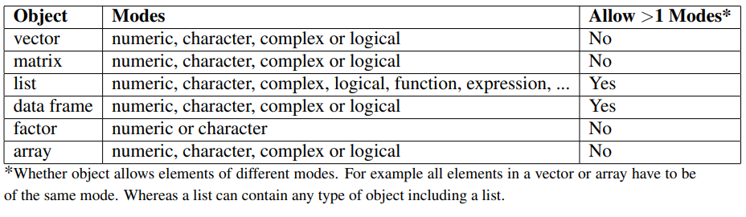

## 2.3 Creating and Accessing Objects

We have already created a few objects: x, y, junk. Will create a few more and will select, access and modify subsets of them.

* Create vectors, matrices and data frames using *seq, rep, rbind* and *cbind*

|  |
| --- |
| # Vector  x.vec = seq(1, 7, by = 2)  # The function seq is very useful, have a look at the help on seq  names(x.vec) = letters[1:4]  xMat = cbind(x.vec , rnorm(4), rep(5,4)  yMat = rbind(1:3, rep(1,3))  z.Mat = rbind(xMat, yMat)  x.df = as.data.frame(xMat)  names(x.df) = c(“ind”, “random”, “score”) |

* Accessing elements: NOTE use square brackets to access elements. The number of elements within the square bracket must equal the dimension of the object.
  + vector[1]
  + matrix[1,1]
  + array with 3 dimensions [1,1,1]

|  |
| --- |
| x.vec[1]  x.vec[“a”]  xMat[,-c(1)]  # Quick Exercise: What does this command do?  xMat[xMat[,1] > 3, ] |

If the object has class data.frame or list, you can use the dollar symbol $ to access elements. The $ can only access columns of data.frame

|  |
| --- |
| colnames(x.df)  x.df$ind  x.df[,1]  names(newList1)  newList1$a |

## 2.4 Modifying elements

|  |
| --- |
| # Change the element of ‘xMat’ in the third row and first column to ‘6’  xMat[3, 1] = 6  # Replace the second column of ‘z.mat’ by 0’s  z.mat[, 2] = 0 |

2.4.1 Sorting and Ordering Items

Frequently we need to re-order the row/columns of a matrix or see the rank order or a sorted set elements of a vector.

The functions *sort* and *order* are designed to be applied on vectors. Sort returns a sorted vector. Order returns an index which can be used to sort a vector or matrix.

|  |
| --- |
| # Simplest ‘sort’  z.vec = c(5, 3, 8, 2, 3.2)  sort(z.vec)  order(z.vec) |

Sorting the rows of a matrix. We will use an example dataset in R called ChickWeight. First have a look tat the ChickWeight documentation (help).

Lets take a subset of the matrix, say the first 36 rows.

|  |
| --- |
| ?ChickWeight  ChickWeight[1:2, ]  Chick.short = ChickWeight[1:36, ]  # Now order this matrix by time and weight  chickOrd = chick.short[order[chick.sort$weight), ]  chickOrd[1:5, ]  # By both time and weight  chick.str = chick.short[order(chick.short$Time, chick.short$weight), ]  chick.srt[1:5, ] |

### 2.4.2 Missing Values

Missing values are assigned special value of *‘NA’*

|  |
| --- |
| z = c(1:3, NA)  z  ind = is.na(z)  ind |

To remove missing values from a vector

|  |
| --- |
| print(z)  x = z[!is.na(z)]  print(x) |

Check to see if a vector has all, any or a certain number of missing values. These create logical vectors which can be used to filter a matrix or data.frame

|  |
| --- |
| all.(is.na(z))  any(is.na(z))  sum(is.na(z))  sum(is.na(z)) > 1 |

### 2.4.3 Creating Empty Vectors and Matrices

To create an empty vector, matrix or data.frame

|  |
| --- |
| x1 = numeric()  x2 = numeric(5)  x1.mat = matrix(0, nrow = 10, ncol = 3) |

## 2.5 Quick Recap

* R Environment, interface, R help and R-project.org and Bioconductor.org website
* Installing R and R packages.
* assignment <-, = , ->
* operators ==, != , <, >, Boolean Operators &, |
* Management of R session, starting session, *getwd(), setwd(), dir()*
* Listing and deleting objects in memory, *ls(), rm()*
* R Objects

|  |  |  |
| --- | --- | --- |
| Objects | Modes | Allow > 1 Modes |
| Vector | Numeric, character, complex or logical | No |
| Matrix | Numeric, character, complex or logical | No |
| List | Numeric, character, complex, logical, function, expression, .. | Yes |
| Data.frame | Numeric, character, complex or logical | Yes |
| Factor | Numeric or character | No |
| Array | Numeric, character, complex or logical | No |

*Whether object allows elements of different modes. For example all elements in a vector or array have to be of the same mode. Whereas a list can contain any type of object including a list.

There are other objects type include *ts(*time series) data time etc. See the R manual for more information. All R Objects have the attributes mode and length.

* Creating objects: c(), matrix(), data.frame(), seq(), rep(), etc
* Adding rows/columns to a matrix using rbind() or cbind()
* Subsetting/Accessing elements in a vector(), matrix(), data.frame(), list() by element name or index.

## 2.6 Exercise 1

For this exercise we will work on data from a study which examined the weight, height and age of women. Data from the women Study is available as an R dataset and information about this study can be found by using R help(hint?women) which we will read directly from the website.

Basic tools for reading and writing data are respectively: *read.table()* and *write.table().* We will go into further details about each later today, but first lets read in this file by typing thse commands:

|  |
| --- |
| myURL <- "http://bcb.dfci.harvard.edu/˜aedin/courses/Bioconductor/Women.txt" women <- read.table(myURL, sep = "\t", header = TRUE) |

1. Get help on the command colnames
2. What is the class of this dataset?
3. How many rows and columns are in the data? (hint try using the functions str, dim, nrow and ncol).
4. Use the summary(), to view the mean height and weight of weomen.
5. Compare the result to using the function colMeans.
6. How many women have a weight under 120?
7. What is the average height of women who weigh between 124 and 150 pounds (hint: need to select the data, and find the mean).
8. Sort the matrix *women* by ‘weight’ hint use order.
9. Give the 5th row the name “Lucy”.